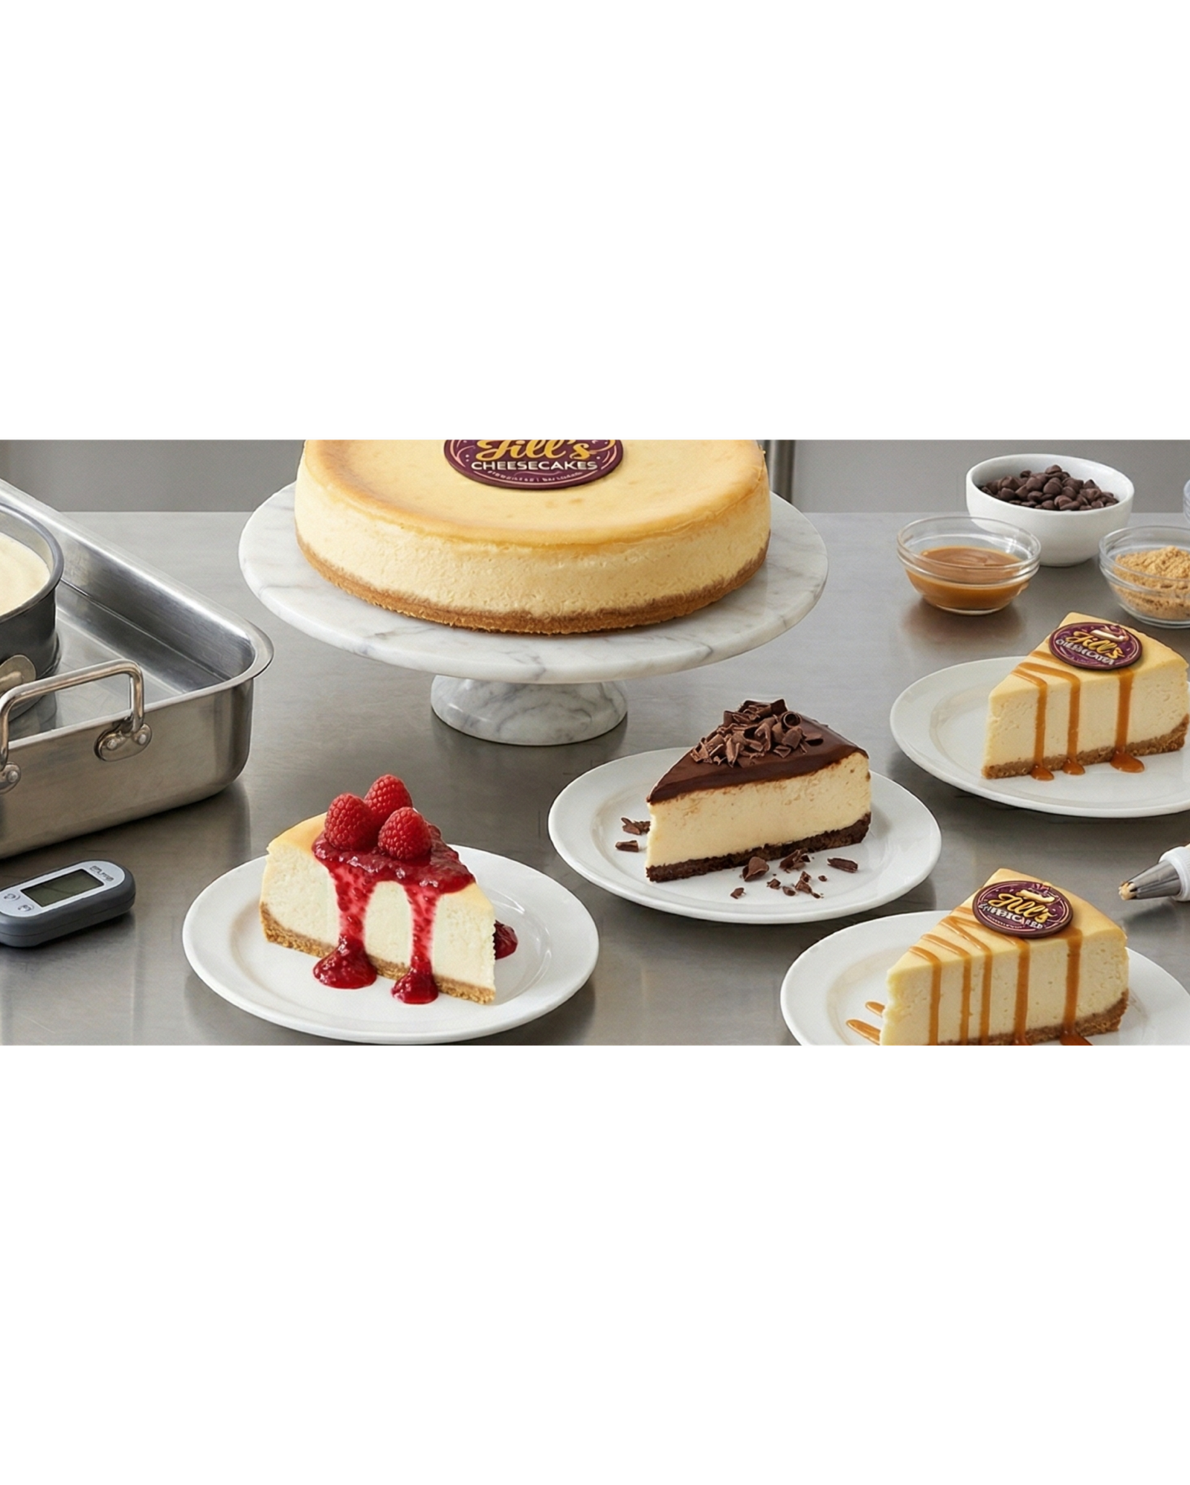

Module 11 Workbook

Business Reality
Understanding Cost, Pricing and Profit
Name:
Date:

Module 11:
Understanding opportunities, ideas and local entrepreneurship.
By the end of this module, you will:
- Understand how money works in a business, including value, costs, and profit
- Learn how to identify costs and set realistic pricing
- Explore what makes a product or service valuable
- Begin applying simple calculations to your own business ideas

Task 1: If you sell something for £10, do you make a £10 profit? Why or why not?
Use the box below to write down your thoughts/ideas.

Task 2: Complete the pre-session survey.

Task 3: Use the space on this page to take notes during the video.
Think about:
- What makes Jill’s Cheesecakes valuable?
- Why is pricing important?
- What surprised you?

Task 4: What are 3 things that make a product or a service valuable?

Task 5: Does value mean the same to everyone? Why?

Task 6: Match the correct description to each title.
Cost | is the "keepable" money left in your pocket; it is the "win" you get once you subtract your total costs from your price
Price | is the total amount of money you spend to make your product or service a reality, including everything from raw materials and packaging to the value of your own time.
Profit | is the specific figure you choose to charge your customers; the actual amount of money they hand over to you when they make a purchase.

Task 7: Using your notes from each section of the video; answer the following questions:
What did you see that costs money?

What might people forget to include?

Task 8: The Pricing Challenge. Fill in the unanswered boxes using the formula on the PowerPoint.
Business Idea | Cost (to make/run) | Price (to customer) | Profit (your take-home)
- Customised Phone Cases | £4.50 | £15.00 | £
- Personal Training Session | £12.00 | £ | £28.00
- Organic Dog Treats | £ | £8.50 | £5.00
- Vintage Clothing Resale | £14.00 | £35.00 | £
- Freelance Web Design | £40.00 | £ | £210.00
- Eco-friendly Tote Bags | £ | £12.00 | £7.50

Task 9: Jill’s Cheesecake Costs £12 to make. Whole Cheesecake Price = £36
Calculate the profit:
£36 – £12 = £

Thinking Deeper
Why do you think Jill priced her cheesecakes as “luxury”?

Task 10: Jill started with her dream income first.
What is your dream monthly income? £____________

Why did you choose this amount?

Task 11:
If your dream income is: £5,000 per month
And you make: £24 profit per item
How many do you need to sell?

£5000 ÷ £24 = _________

Task 12: Your business idea:
My business idea is:

My costs are:
Use this space to work out your costs.
☐ Materials
☐ Time
☐ Marketing
☐ Equipment
☐ Travel
☐ Other

My total estimated costs are:

I would charge the customer:

My profit would be:

Task 13: Thinking about value…
Do you have:
☐ Skills
☐ Qualifications
☐ Experience
☐ Creativity
☐ Unique ideas
How do these increase your value?

Task 14:
One thing I learned about pricing:

One thing I will do differently:

Task 15: Now complete the post-session survey.

Optional Extra Task: Create a basic business plan

My dream income:

Product Price:

Cost:

Profit:

How many do you need to sell?

