
Operating During Uncertainty – My Stability Plan

Section 1 – The Uncertainty Audit
What is the main thing currently making your business feel unstable?
Writing it down reduces its power.

Section 2 – The Control Map
Fill the circles:
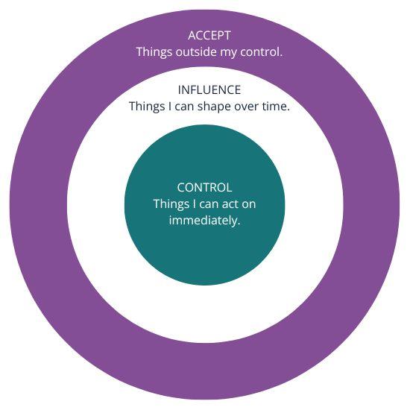
Focus energy on the centre circle.

Section 3 – The Stability Checklist
Financial:
One action I can take to understand my numbers better:

Operational:
One task I can simplify this week:

Personal:
One habit that protects my energy:

Section 4 – The 72-Hour Rule
I am tempted to change:

Because I feel:

I will review this decision on:

Section 5 – Reflection
Right now I am:
☐ Reacting to fear
☐ Responding to facts
What is the next calm action I can take?

