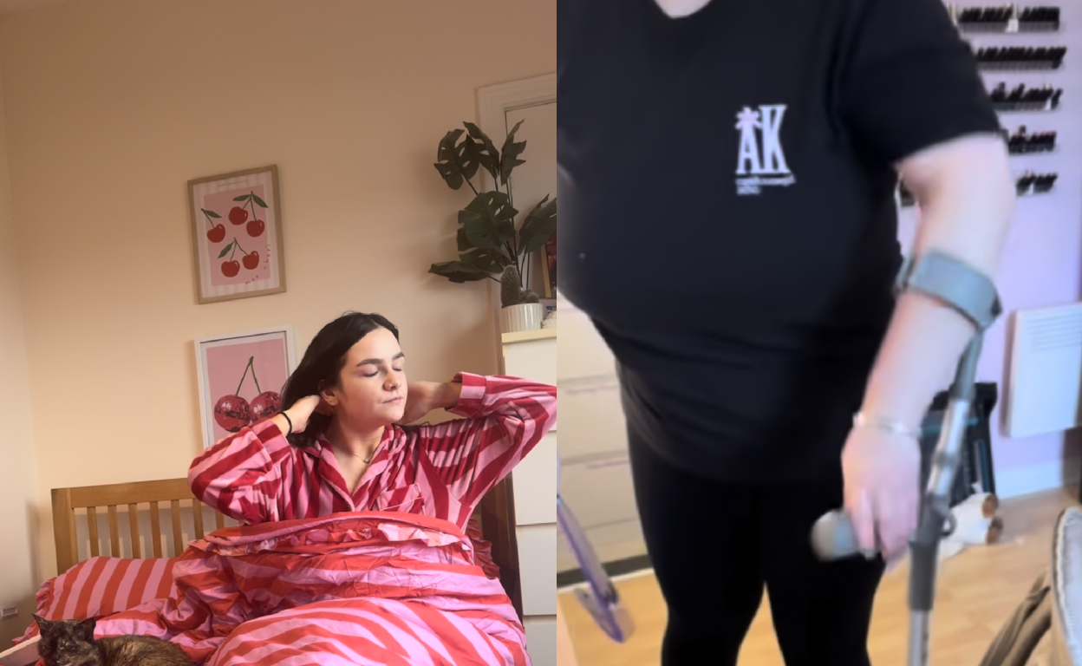
Module 5 Workbook

Build Your Business
Responsible Business and Event Design
Name:
Date:

Module 5:
Understanding opportunities, ideas and local entrepreneurship.
By the end of this module, you will:
- Understand the importance of fair work, accessibility, and inclusion
- Explore how different people experience businesses and environments
- Identify barriers that may impact others
- Learn how small changes can create more inclusive and supportive spaces

Task 1: Do you think events or businesses are usually accessible for everyone?
Use the box below to write down your thoughts/ideas.

Task 2: Complete the pre-session survey.
Task 3: Write down your thoughts on the following questions:
What is Fair Work?

What does inclusion really mean?

How do small choices make a different?

Task 4: Watch the video and take notes in the space below:

Task 5: Spot the differences: Now you have watched the video, can you identify the decisions each business owner needed to make or consider?
Kirsty needed to think about…

Kara needed to think about…

Task 6: Scenario: Listen to the transcript about the pathways event. After listening to the audio, choose from one of the 3 scenario prompts, then and answer the following questions on your chosen scenario.
What barriers did you notice at this event?

Who might be affected by these barriers?

How might these barriers make someone feel or impact their experience?

Which of these issues are about accessibility in which are about Inclusion?

What is one small change that could have been Improved for this event?

Task 7: Designing a responsible event, independent task. Choose one of the event options from the PowerPoint. Then work our way through the following activity.
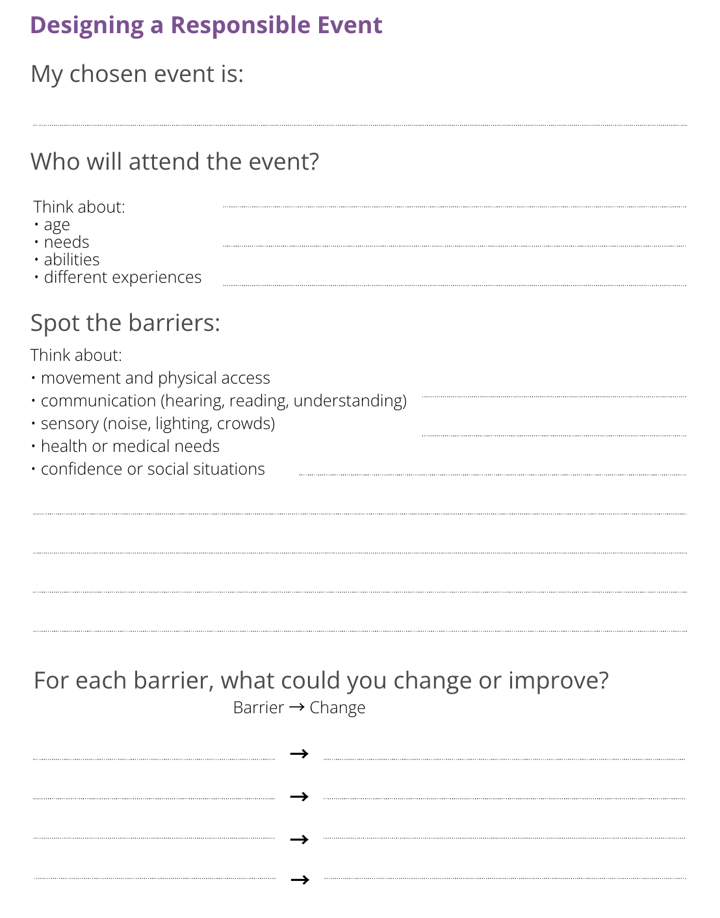

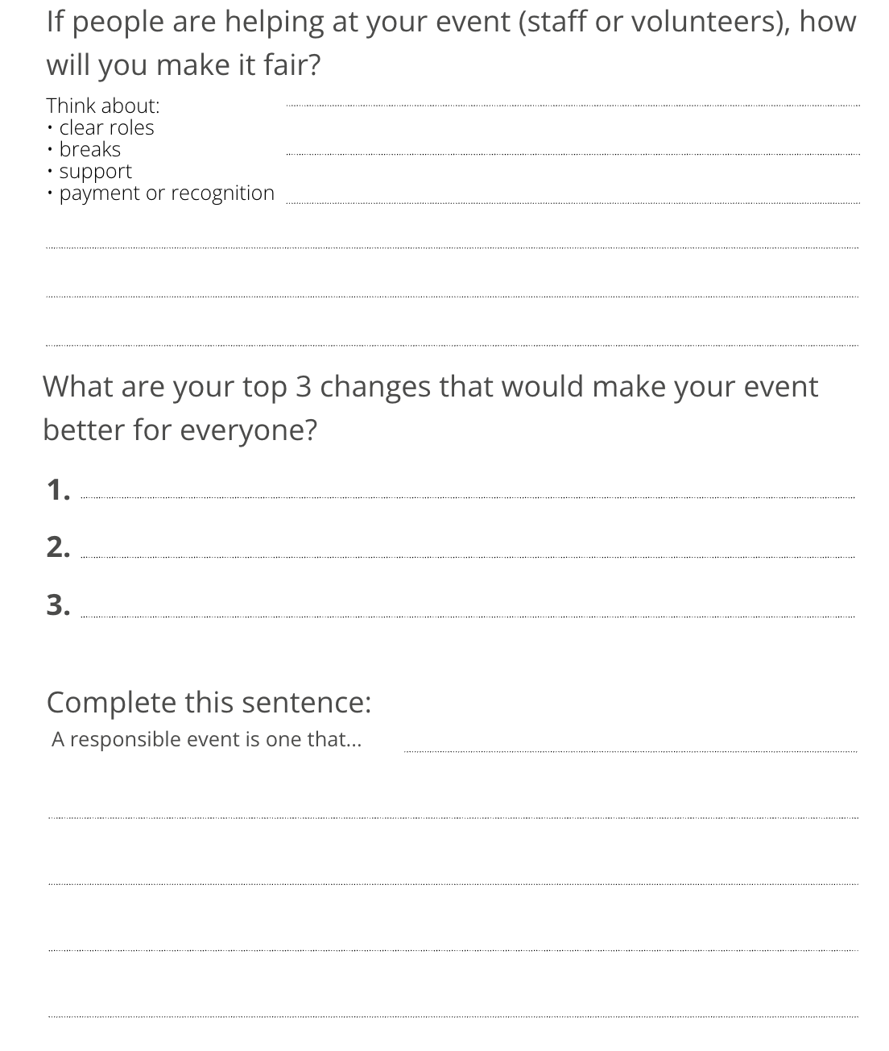
Scenario Activity Helpful Notes:
Barrier Identification → Inclusion → Action
1. Spot the Barriers
- What barriers can you see in this event setup?
- Are there any parts of the event that might be difficult to access or take part in?
- What might be easy for some people but harder for others?
2. Think About Different People
- How might this event feel for someone who uses a wheelchair or has limited mobility?
- What about someone who is deaf or hard of hearing?
- How would someone who is blind or visually impaired experience this event?
- How might this environment feel for someone with sensory sensitivities (noise, lighting, crowds)?
- What challenges might someone with a learning difficulty or learning disability face?
- How might someone with a chronic illness or fatigue experience this event?
- What about someone with allergies or medical conditions, is anything missing for them?
3. Inclusion & Experience
- Would everyone feel welcome at this event? Why or why not?
- Are there any parts of the event that might make someone feel excluded or uncomfortable?
- Does this event assume that everyone communicates, moves, or interacts in the same way?
4. Improve the Event
- What is one change that could remove or reduce each barrier you’ve identified?
- What small adjustments could make the biggest difference?
- What could be planned differently from the start to include more people?
- How could you give people different ways to take part?
5. Bringing It Together
- If you had to improve this event using just three changes, what would you prioritise?
- Why are these changes important for creating a fair and responsible business or event?

Task 8: Now complete the post-session survey.

