
Module 1 Workbook

Entrepreneurial Thinking
Enterprise in the South of Scotland
Name:
Date:

Module 1:
Understanding opportunities, ideas and local entrepreneurship.
By the end of this module, you will:
- Explore what enterprise means and how it shows up in everyday life
- Discover local businesses and opportunities within the South of Scotland
- Understand how businesses create impact in communities
- Begin thinking about how ideas can turn into opportunities

Task 1: What does “enterprise” mean to you?
Use the box below to write down your thoughts/ideas.

Task 2: Complete the pre-session survey.
Task 3: What is enterprise?
Use the box below to write/draw your observations from the video.

Task 4: Group Activity: How many businesses can you identify in your local area?

Task 5: Group Activity:
Work in small groups to identify a local problem and "pitch" an enterprising solution using the four pillars of enterprise.

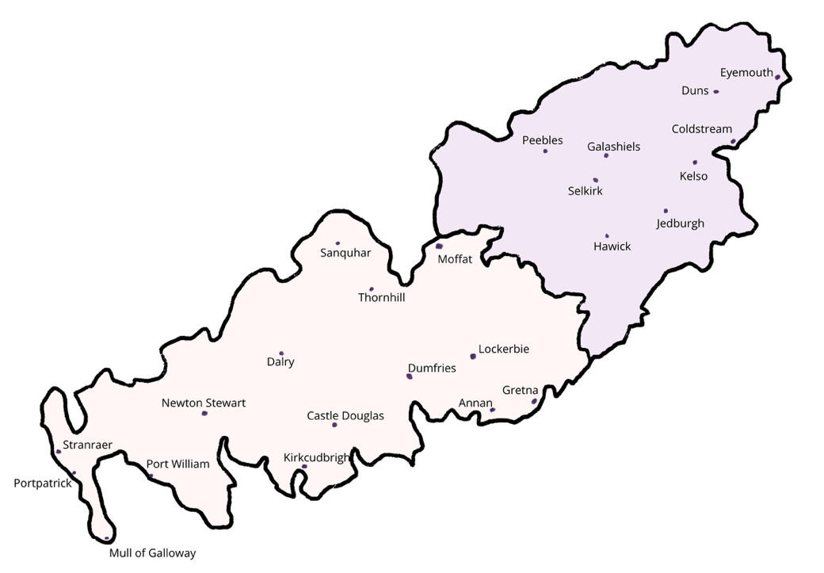

Task 6: Can you think of a business or project that has helped your local community?

Task 7: Now complete the post-session survey.

