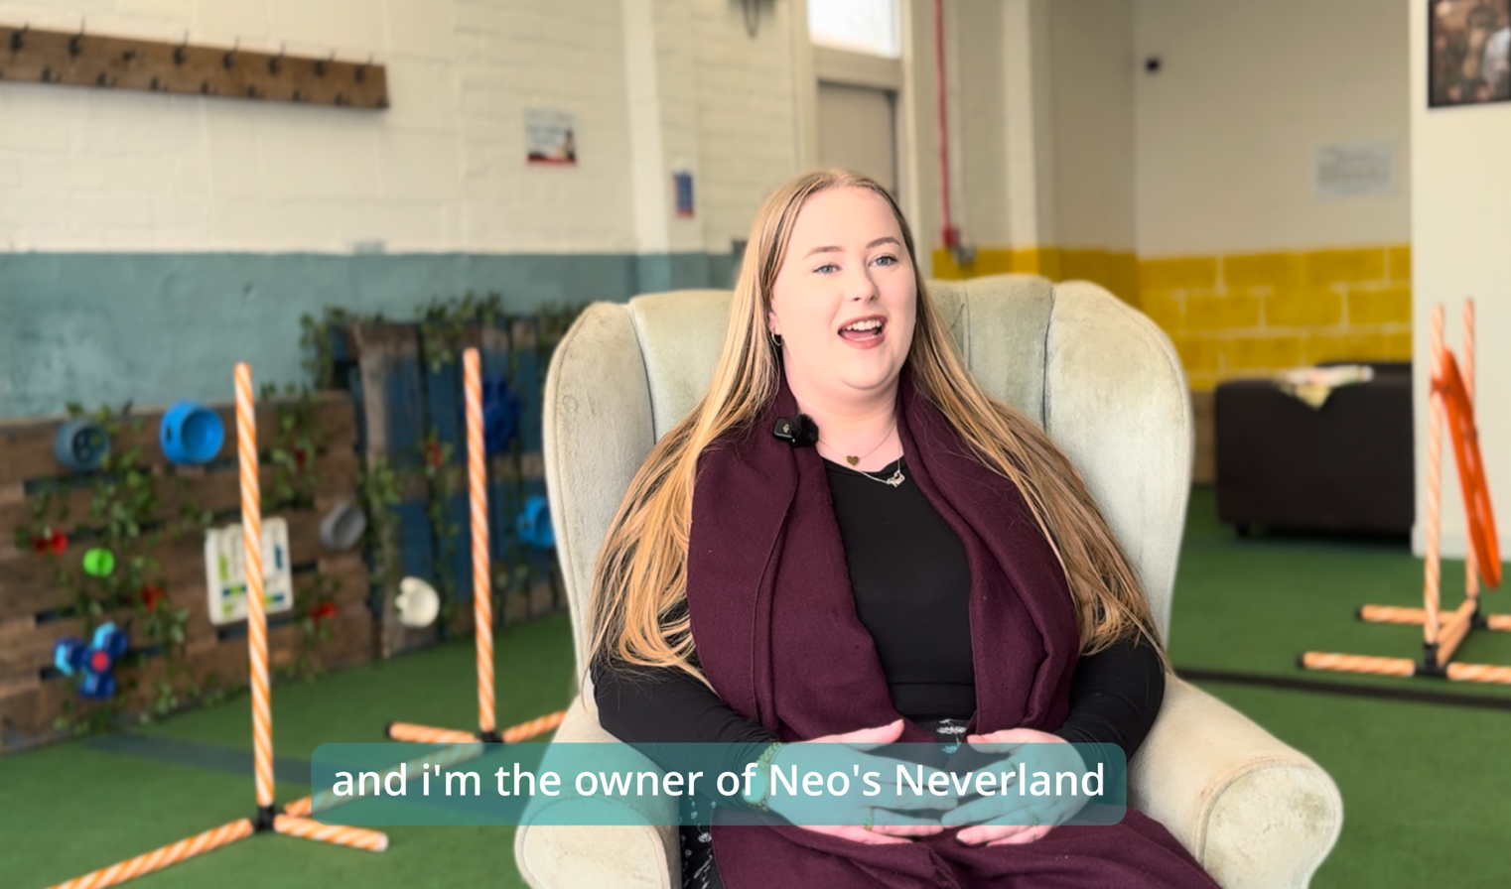
Module 4 Workbook

Understanding Your Ideas
Understanding Your Customers
Name:
Date:

Module 4:
Understanding opportunities, ideas and local entrepreneurship.
By the end of this module, you will:
- Learn why knowing your customer is key to building a successful idea
- Identify who a product or service is designed for
- Explore the connection between problems, needs, and solutions
- Begin thinking about your ideal customer and their experiences

Task 1: Who do you think the products are for?
Use the box below to write down your thoughts/ideas.

Task 2: Complete the pre-session survey.
Task 3: Think about a dog walking service, then answer the following:
Who is the customer?

What problem are they solving?

What is their solution?

Task 4: Think about your business idea The answer the following question:
My business is not for everyone because…

Task 5: My Ideal Customer

They are my idea customer because…

Task 6: Watch the case study and takes notes on who their customer is, what problem do they solve, and what did they do to gain a bigger audience?

Task 7: Analytic Deep Dive
What changes did Kindling Minds make to increase their views and engagement?

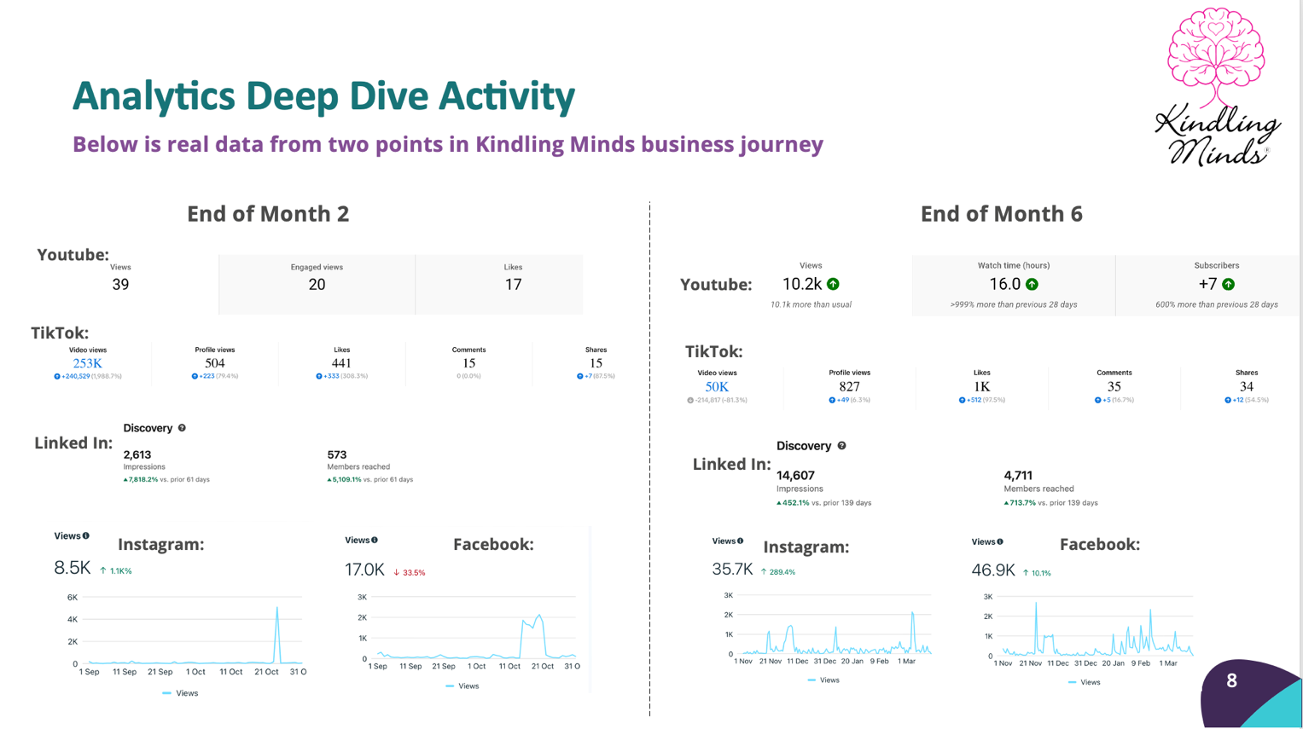

Task 8: Look at the business timeline. Does Kindling Minds understand their customer? What should they do going forward for their customers?

Task 9: Now complete the post-session survey.

