Module 12 Workbook

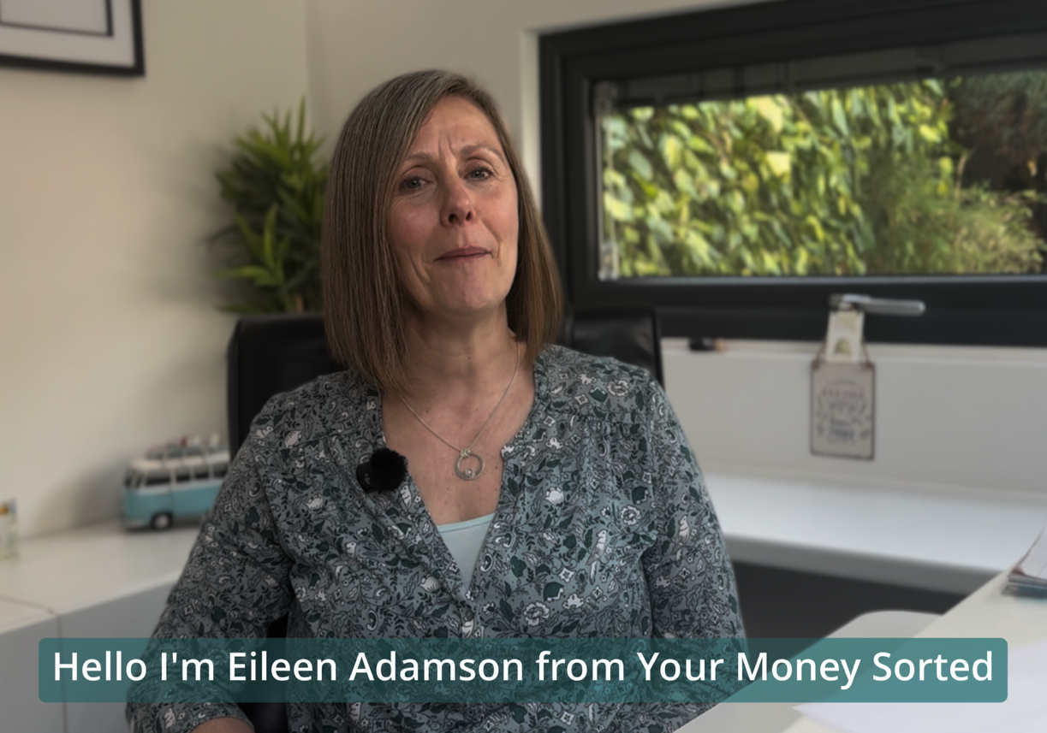

Business Reality
Understanding Business vs Personal Money
Name:
Date:

Module 12:
Understanding opportunities, ideas and local entrepreneurship.
By the end of this module, you will:
- Understand the difference between personal and business money and why keeping them separate matters
- Explore how businesses track income, expenses, and profit to make informed decisions
- Understand why saving for tax and staying organised helps reduce stress
- Identify simple tools and habits that can help you manage your business money effectively

Task 1: Why does knowing about money matter?
Use the box below to write down your thoughts/ideas.

Task 2: Complete the pre-session survey.

Task 3: Starting a business means understanding your money. Knowing your numbers helps you make better decisions and grow your business?
Use the box below to write/draw your observations from the video.

Task 4: Answer the two questions below:
What worries you most about business money?

What would help you feel more confident?

Task 5: Separate your money.
Work in small groups and discuss why mixing personal and business money can cause problems? Write your ideas below:

Task 6: You earn £200 from your business.
How might you divide it? Tax savings | Business expenses | Profit
Write your ideas below:
Tax: £
Expenses: £
Profit: £

Task 7: Saving for Tax. If you earn the following how much is 20% tax?
- £100 Tax = £

- £250 Tax = £

- £300 Tax = £

Why might saving monthly make tax less stressful?

Task 8: Keep Receipts
Why do businesses keep receipts?
Tick all that apply:
☐ Track spending
☐ Pay tax correctly
☐ Understand profit
☐ Stay organised
Which tools might help you most?

Task 9: Monthly Money Date. Create your own money date:
Where? __________________________ When? __________________________
What will you check?
☐ Income
☐ Expenses
☐ Profit
☐ Payments

Task 10: Zone of Genius
What are you good at?

What would you ask for help with?

Task 11: Final Thoughts
One thing I learned about business money:

One thing I will do differently:

Task 11: Now complete the post-session survey.

