Module 6 Workbook
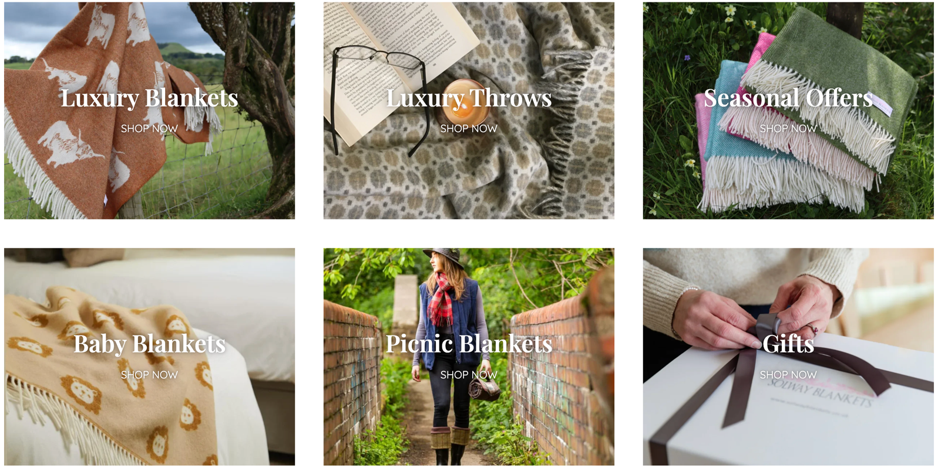


Building Your Business
Sustainable and Responsible Business
Name:
Date:

Module 6:
Understanding opportunities, ideas and local entrepreneurship.
By the end of this module, you will:
- Explore what sustainability means in a business context
- Understand how businesses impact people, communities, and the environment
- Identify values that influence decision making
- Learn how businesses can create positive, long-term impact

Task 1: What 3 words would you like your business to be known for?
Examples: Kind, sustainable, supportive, loud, bold, inspiring

Task 2: Complete this sentence:
To me, a successful business is one that…

Task 3: Complete the pre-session survey.

Task 4: Write one example of sustainability you have seen in real life.

Task 5: Group Activity:
Choose 3 businesses from your local area. One that is people focused, one that is planet focused and one that is profit focused. Explain why you choose each one.
People focused business:

Planet focused business:

Profit focused business:

Task 6: Solway Blankets. Take notes whilst watching the video.

Task 7: From the video:
What is important to this business?
☐ Helping the environment
☐ Helping people
☐ Quality products
☐ Supporting local
☐ Other:

Task 8: Finish the following sentences:
Solway Blankets prioritise….

They prioritise this because….

Sustainability impacts their decision making because…

Task 9: If you had a business, one thing you would do to help people or the environment is…

Optional Task: If you were building your business:
What values would guide your decisions?

What would you refuse to compromise on?

What challenges might you face?

Task 10: What would you not compromise on in a business?

Task 11: Why might a business pretend to be sustainable?

Task 12: Spot the ‘Fluff’. Which claim is greenwashing and why?

Task 13: Now complete the post-session survey.

