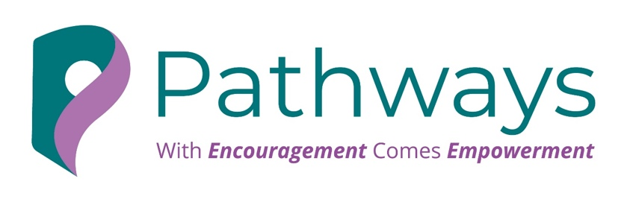

CONFIDENCE COMES AFTER ACTION
Founder Action Worksheet
In business, confidence is rarely the starting point. It is built through action, evidence, and repetition.
Use this worksheet to identify where hesitation is slowing momentum and define the next bold step that moves you forward.

1. Where am I currently holding back?
What conversation, decision, opportunity, or action am I delaying because I do not yet feel confident enough?
____________________________________________________________________________________________________________________________________________________________________________________________________________________________________________________________________________________________________________________________________________________________________________

2. What is the business opportunity or next move?
What do I need to do, say, start, ask for, or put in motion?
____________________________________________________________________________________________________________________________________________________________________________________________________________________________________________________________________________________________________________________________________________________________________________

3. What is driving the hesitation?
What doubts, risks, or fears are showing up?
Examples:
- Getting it wrong
- Being judged
- Making the wrong decision
- Being visible
- Rejection
- Not feeling fully ready
____________________________________________________________________________________________________________________________________________________________________________________________________________________________________________________________________________________________________________________________________________________________________________

4. What is a more useful, commercially strong perspective?
Replace fear-based thinking with a more balanced and effective mindset.
Examples:
- I do not need complete confidence to take the next step
- Action creates clarity
- Discomfort is part of growth
- I can act before I feel fully ready
- Small moves build momentum
____________________________________________________________________________________________________________________________________________________________________________________________________________________________________________________________________________________________________________________________________________________________________________
5. What is one bold but manageable action I can take next?
Choose a step that is specific, realistic, and forward-moving.
My next action is:
______________________________________________________________________________________________________________________________________________________________________________________
I will complete it by:
____________________________________________________________________________________________________________________________________________________________________________________________________________________________________________________________________________________________________________________________________________________________________________

6. Why does this action matter?
How does this support growth, visibility, decision-making, leadership, or momentum?
____________________________________________________________________________________________________________________________________________________________________________________________________________________________________________________________________________________________________________________________________________________________________________

7. What am I predicting will happen?
What outcome am I worried about?
____________________________________________________________________________________________________________________________________________________________________________________________________________________________________________________________________________________________________________________________________________________________________________

8. What actually happened?
Complete this after taking the action.
____________________________________________________________________________________________________________________________________________________________________________________________________________________________________________________________________________________________________________________________________________________________________________

9. What evidence did this give me?
What did this action show me about my capability, resilience, or leadership?
____________________________________________________________________________________________________________________________________________________________________________________________________________________________________________________________________________________________________________________________________________________________________________

10. What is the next action that keeps momentum going?
Confidence grows when action is repeated. What is the next step?

Closing Reflection
Progress is built through action, not waiting. Confidence does not have to come first.
Taking the step is what builds it.



