
Module 13 Workbook


Business Reality
Resilience and Learning from Failure
Name:
Date:

Module 13:
Understanding opportunities, ideas and local entrepreneurship.
By the end of this module, you will:
- Understand that setbacks are a normal part of learning and growth
- Explore thoughts and feelings that arise when things don’t go to plan
- Identify supportive and unhelpful influences (green and red flags)
- Learn strategies to respond to challenges and move forward

Task 1: Write about a time something didn’t go to plan.
Use the box below to write down your thoughts/ideas.

Task 2: Complete the pre-session survey.
Task 3: Write down one thought you have had where you questioned your ability to succeed?

Task 4: Video - Jot down any notes you may have.

Task 5: Answer the following questions using your notes from the video.
One thing that stood out is…

One helpful tip was…

One red flag was….

One green flag was…

Task 6: Red and Green Flag Behaviour and People.
Take your flag handout and on one side colour the flag red, and the other side green.
In the space around your flag’s write down behaviours and people in your life that you would class as red or green flags.
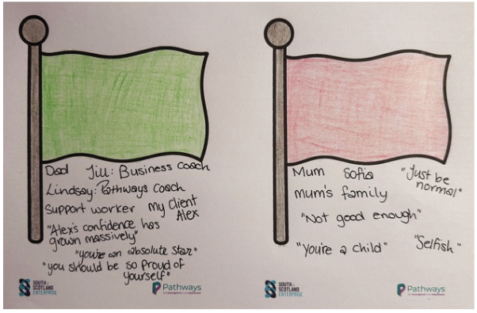
Here’s an example:

Task 7: Creating your own network of support:
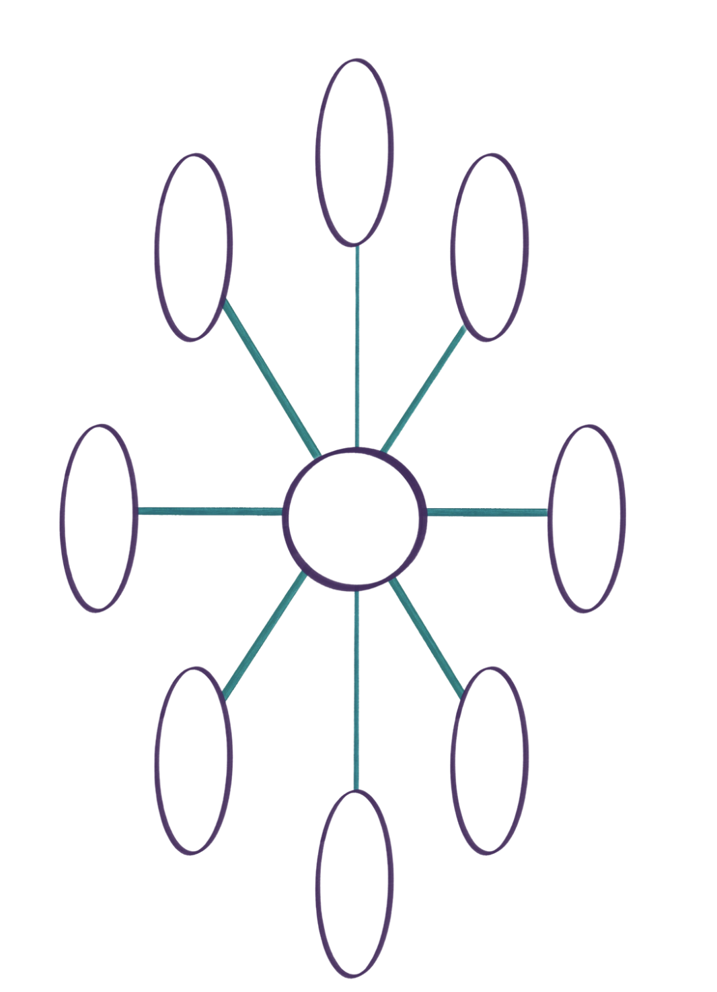
Task 8: Let’s reframe the negative. Think of a time where you have struggled with fear. This could be in your business, life or relationships. Discuss with the people around you, then answer the following questions:

What is the worst thing that could happen?

Then what?

If this happened, I would…

Task 9: What has changed in how you think about failure?

Task 10: Now complete the post-session survey.

