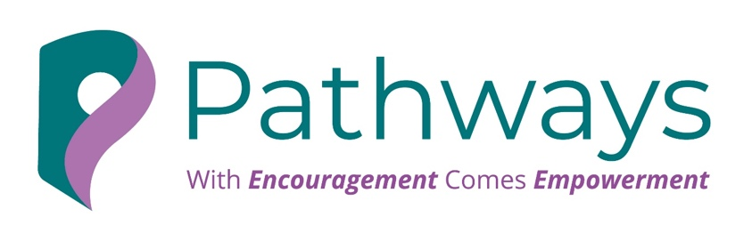

BOUNDARIES FOR SUSTAINABLE SUCCESS
Founder Boundary Reflection Worksheet
In business, boundaries protect the time, energy, and focus that allow sustainable success.
Use this worksheet to reflect on where stronger boundaries may be needed and identify one clear next step.

1. What does sustainable success look like for me?
What do I want success to look like in a way that feels realistic, healthy, and sustainable?
____________________________________________________________________________________________________________________________________________________________________________________________________________________________________________________________________________________________________________________________________________________________________________

2. What matters most for me to protect right now?
What do I need to protect more carefully in this season of work or business?
____________________________________________________________________________________________________________________________________________________________________________________________________________________________________________________________________________________________________________________________________________________________________________

3. What tends to make me say yes too quickly?
What thoughts, fears, or pressures make it harder for me to pause and choose clearly?
Examples:
- Fear of disappointing people
- Fear of losing an opportunity
- Wanting to be helpful
- Guilt or avoiding awkwardness
- Financial pressure
- Habit
____________________________________________________________________________________________________________________________________________________________________________________________________________________________________________________________________________________________________________________________________________________________________________

4. What are my warning signs that a boundary is needed?
What do I notice in my mind, body, or behaviour when something is no longer fitting with my capacity, values, or needs?
Examples:
- Poor sleep
- Tension or overthinking
- Frustration or irritability
- Dread or feeling mentally crowded
- Feeling constantly behind
____________________________________________________________________________________________________________________________________________________________________________________________________________________________________________________________________________________________________________________________________________________________________________

5. Where am I currently feeling stretched?
Where in my work or business do I feel pressure, overload, resentment, or lack of control?
____________________________________________________________________________________________________________________________________________________________________________________________________________________________________________________________________________________________________________________________________________________________________________

6. What does saying yes too often cost me?
When I overcommit, what am I often saying no to?
____________________________________________________________________________________________________________________________________________________________________________________________________________________________________________________________________________________________________________________________________________________________________________

7. What is a go, not now, and no go for me?
What is a clear yes, what may be possible later, and what is no longer realistic or acceptable?
____________________________________________________________________________________________________________________________________________________________________________________________________________________________________________________________________________________________________________________________________________________________________________

8. Where do I most need a stronger boundary right now?
What one area of work or business would benefit most from a clearer limit or decision?
____________________________________________________________________________________________________________________________________________________________________________________________________________________________________________________________________________________________________________________________________________________________________________

9. What boundary do I need to put in place?
Write it simply and clearly.
____________________________________________________________________________________________________________________________________________________________________________________________________________________________________________________________________________________________________________________________________________________________________________

10. What could I say?
Write one or two boundary statements in language that feels natural and professional.
____________________________________________________________________________________________________________________________________________________________________________________________________________________________________________________________________________________________________________________________________________________________________________

Closing Reflection
Sustainable success is built on clarity, self-respect, and boundaries that protect what matters most.
The one boundary I most need to honour is:
____________________________________________________________________________________________________________________________________________________________________________________________________________________________________________________________________________________________________________________________________________________________________________



